Comparative Analysis
On-Demand Home Services in Kathmandu

Prepared for: Sriyog Consulting
Prepared by: Sadikshya Karki

Date: June 2026
Research Scope: Kathmandu, Nepal

1. Introduction
This report presents a comparative analysis of the on-demand home service market in Nepal, based on a dataset covering 40 distinct service categories. The dataset was compiled by identifying the companies, platforms, and individuals that currently offer each service, along with the type of provider behind each listing and the website or page through which the service can be accessed. In total, 314 individual provider listings were recorded across the 40 categories, with providers classified into eight broad types ranging from organized companies and app or marketplace platforms to listings and directory sites, brand authorized service centres, individual or informal providers, organized construction companies, organized clinics, and an organized home healthcare company.
The purpose of this analysis is to compare how the market is structured across categories and provider types, to identify which services are crowded with competition and which remain underserved, and to highlight the providers that operate across the widest range of categories. The findings are organized into three areas of comparison, namely the distribution of listings across broader sectors, the distribution of providers by type, and a category-by-category comparison of competitive intensity.

2. Sector Wise Distribution
The 40 service categories were grouped into five broader sectors to compare how provider activity is spread across the market. The table below shows the number of provider listings and the corresponding share for each sector.
Table 1: Sector Wise Distribution of Provider Listings
Service Sector | No of Listings | Share | Service Categories
Home Repair and Renovation | 113 | 36.0% | Masonry Repair, Plumbing Repair, Carpentry, Painting, Home Renovation, Drywall Repair, Tiling, False Ceiling, Aluminium Fabrication, Parqueting, Modular Kitchen, Handyman
Technical and Appliance Services | 84 | 26.8% | Electrical Repair, Washing Machine Repair, AC Services, Refrigerator Repair, CCTV Services, Computer Repair, Geyser Repair, Chimney Repair, EV Charger Installation, Home Automation, Lift or Elevator Repair
Cleaning and Outdoor Maintenance | 56 | 17.8% | Deep Cleaning, Garden Care, Pest Control, Water Tank Cleaning, Septic Tank Cleaning, Tree Cutting and Pruning, Indoor Planting
Personal Care and Wellness | 44 | 14.0% | Bridal Makeup, Salon at Home, Spa at Home, Massage Therapy, Physiotherapy, Pet Grooming, Chef at Home
Specialized and Other Services | 17 | 5.4% | Packing and Moving, AirBnB Maintenance, RO Water Purifying

Home repair and renovation form the largest sector of the market, accounting for more than a third of all provider listings. This sector includes structural and finishing work such as plumbing, carpentry, painting, tiling, and modular kitchen installation, all of which require recurring attention in most households and therefore attract a wide base of providers. Technical and appliance services form the second largest sector, reflecting steady demand for electrical work, AC and appliance servicing, and home security installation in urban households. Cleaning and outdoor maintenance and personal care and wellness together make up close to a third of the market, while specialized services such as packing and moving, water purifier servicing, and AirBnB property maintenance remain a small but distinct segment with far fewer providers.

3. Provider Type Distribution
Every provider in the dataset was classified into one of eight types based on how it operates. The table below compares these provider types by the number of listings and the share of the overall market each type represents.
Before comparing provider types by listing count, it helps to understand what each type means:
- Organized company: A registered business that delivers services directly to customer under its own brand
- App or marketplace platform: A digital platform or app that connects customers with service providers without delivering the service itself
- Listings or directory: A website that lists service providers for discovery purposes only, without facilitating booking or delivery
- Individual or informal: A freelancer or self-employed individual who offers services through social media or word of mouth without a formal business structure
- Brand authorized service centre: A workshop or outlet officially authorized by a manufacturer to service or repair its specific products
- Organized clinic: A registered healthcare or wellness facility offering professional therapeutic services
- Organized construction company: A registered construction firm that takes on structural or renovation projects as its primary business
- Organized home healthcare company: A registered company that sends trained medical or care professionals directly to a patient's home
Table 2: Distribution of Provider Listings by Provider Type and Market Share
Provider Type | No of Listings | Share | Service Providers
Organized company | 151 | 48.1% | Rocket Cleaning Services, Nepal Cleaning Solution, Facility Service, United Facility Service, Modern Cleaning, Clean Master Nepal, Home Care Service Nepal, Multiple Facility Service, Hamro Nursary, Ajima Nursery, KTM Nursery, Royal Cleaning Services, Homeplex Nepal, Hamro Nirman, Repairing Service Nepal, Nepal Construction Mart, Kathmandu Technician, ReshapeHome, Home Repair Nepal, Home Plumbing Nepal, Kathmandu Repair Service, AC Ghar, AirCharged, Mega Solar Energy, Multi Power Solution, House Maid Agency Nepal, Top Ten Packers and Movers, Ramro Packers and Movers, Easy Packers and Movers, Nepal Packers and Movers, Shift Mandu Packers and Movers, Namaste Packers and Movers, Houserz, Sams Property, Ananeke Beauty Salon, Furnisia Interiors, Hamro Kitchen Interior, Ultra Interio, Parquet Interior, PK Traders Nepal, SR Modular Kitchen and Parquet Center, False Ceiling House, Spa Service At Home, Sunflower Spa Nepal, Leon Traders Nitco Tiles, Miummium, Smart Things Nepal, Eco Parquet, Code Space Services, Marmat Mistri, Body Massage Home Service, Aluminium Fabricators Nepal, Sanam, ANS Aluminium, Bhattarai Engineering, Pet Spa, My Pet Mama, City Pet House
App or marketplace platform | 117 | 37.3% | Kucho, Technical Sewa, Online Thekedar, Doorsteps Nepal, CareConnect Nepal, NepFix, Mali Nepal, Garden Sewa, Sajilo Sewa, QuickFix, Skill Sewa, HomeWork Nepal, SmartCare, Smart Home Sewa, Chito Sewa, SipMandu, Trade Nepal Online, Gharbanau, Wozoop, Online Sewa, TakeAChef, Doc.com.np, Sajilo
Listings or directory | 20 | 6.4% | Khojnu, WedTayari, TurantCall, Mero Event, TheNimto, Hamro Mistri, NepalYP, Callmandu, Nepal Yellow Pages
Individual or informal | 12 | 3.8% | Razzu Shrestha, Makeup by Bhumeeka, Swechchhya Makeup and Team, Modular Kitchen Boudha, Groomfy Home Salon, Midas Touch Nepal, Beauty Parlor Kathmandu Home Service, Beauty Home Service, Surya Parquet, All Tropical Plant House, Garden in Room, Elevators Nepal
Brand authorized service centre | 8 | 2.5% | Authorized Service Centre Nepal, Godrej Interio Kitchen Nepal, Frankson Elevator
Organized clinic | 3 | 1.0% | Nirvana Physiotherapy and Wellness Center, National Physiotherapy Rehabilitation Center, TRX Nepal
Organized construction company | 2 | 0.6% | Jadan Construction Group, KSM Nepal
Organized home healthcare company | 1 | 0.3% | Doctors House Call Service

Organized companies form the single largest group of providers in the market, supplying nearly half of all listings. These are independently registered businesses that deliver services directly rather than through a digital intermediary, and they appear across almost every category in the dataset. App or marketplace platforms form the second largest group at just over a third of all listings, showing that digital aggregation has become a well-established channel for booking home services, though it has not yet overtaken the traditional organized business model. Listings and directory platforms, which only display provider information without facilitating the service themselves, make up a much smaller share of the market. Individual or informal providers, brand authorized service centres, organized clinics, organized construction companies, and the single organized home healthcare provider together account for less than nine percent of the market, indicating that these provider types serve narrow or specialized niches rather than the market.
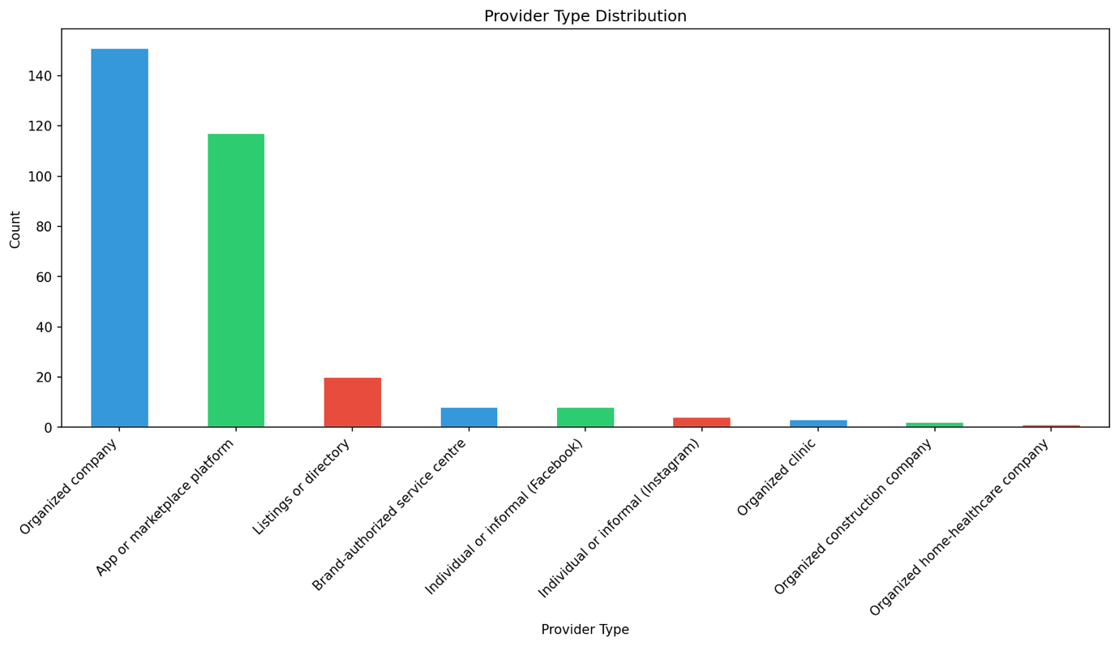
Figure 1: Distribution of Provider Listings by Provider Type

4. Service Category Comparison
The table below compares all 40 service categories by the number of providers identified for each, ranked from the most to the least competitive.
Table 3: Service Category Comparison by Number of Providers and Market Share
Service Category | No of Providers | Share
Plumbing Repair | 20 | 6.4%
Electrical Repair | 19 | 6.1%
Painting | 17 | 5.4%
Deep Cleaning | 14 | 4.5%
AC Services | 14 | 4.5%
Garden Care | 11 | 3.5%
Carpentry | 11 | 3.5%
Bridal Makeup | 11 | 3.5%
Modular Kitchen | 11 | 3.5%
Pest Control | 11 | 3.5%
Salon at Home | 11 | 3.5%
Water Tank Cleaning | 10 | 3.2%
Packing and Moving | 9 | 2.9%
CCTV Services | 9 | 2.9%
Home Renovation | 9 | 2.9%
Tiling | 9 | 2.9%
Aluminum Fabrication | 9 | 2.9%
Computer Repair | 9 | 2.9%
Washing Machine Repair | 8 | 2.5%
Handyman | 8 | 2.5%
Refrigerator Repair | 7 | 2.2%
False Ceiling | 7 | 2.2%
Masonry Repair | 6 | 1.9%
RO Water Purifying | 6 | 1.9%
Spa at Home | 5 | 1.6%
Physiotherapy | 5 | 1.6%
Geyser Repair | 5 | 1.6%
Pet Grooming | 5 | 1.6%
EV Charger Installation | 4 | 1.3%
Parqueting | 4 | 1.3%
Indoor Planting | 4 | 1.3%
Massage Therapy | 4 | 1.3%
Chimney Repair | 4 | 1.3%
Chef at Home | 3 | 1.0%
Tree Cutting and Pruning | 3 | 1.0%
Septic Tank Cleaning | 3 | 1.0%
Lift or Elevator Repair | 3 | 1.0%
AirBnB Maintenance | 2 | 0.6%
Drywall Repair | 2 | 0.6%
Home Automation | 2 | 0.6%

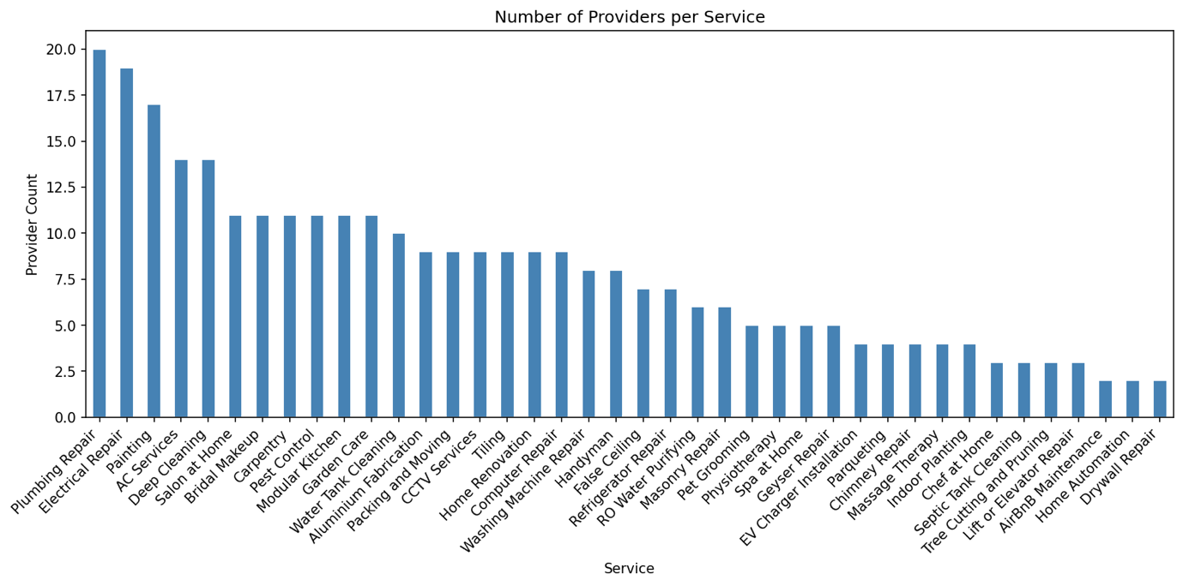
Figure 2: Number of Service Provider

Most Competitive Service Categories
Plumbing repair leads the market with 20 providers, followed closely by electrical repair with 19 and painting with 17. Deep cleaning and AC services are tied at 14 providers each. These categories share a common trait in that they address frequent and unavoidable household needs, and they are served by a wide mix of organized companies and app-based platforms competing for the same customers. Several categories cluster around 11 providers each, including garden care, carpentry, bridal makeup, modular kitchen, pest control, and salon at home, which together form a second tier of moderately competitive services.

Least Competitive Service Categories
At the other end of the market, AirBnB maintenance, drywall repair, and home automation each have only 2 providers, making them the least competitive categories in the dataset. Chef at home, tree cutting and pruning, septic tank cleaning, and lift or elevator repair each have only 3 providers. These categories tend to be newer, more specialized, or dependent on a narrow customer base, which limits the number of businesses willing to enter the space. They represent the clearest opportunities for new entrants seeking categories with limited existing competition.

5. Key Comparative Insights

Multi Category Service Providers
A small number of providers operate across a large share of the 40 categories rather than specializing in a single service. Sajilo Sewa appears in 19 of the 40 categories, making it the most widely present platform in the dataset, followed by Technical Sewa and SmartCare, which each appear in 13 categories. Repairing Service Nepal and Royal Cleaning Services each appear in 11 categories, while Khojnu and Nepal Cleaning Solution each appear in 10. These multi category providers function as horizontal players that compete in nearly every part of the home services market, in contrast to specialized providers such as packers and movers companies or nursery businesses that operate only within a single category.

Formalization of the Market
Combining organized companies, brand authorized service centres, organized clinics, organized construction companies, and the organized home healthcare provider shows that just over half of the market, about 52.5%, is served by formally structured businesses. Digital intermediaries, meaning app or marketplace platforms together with listings and directory sites, account for around 43.6% of the market. Individual or informal providers make up the remaining small share, concentrated mainly in personal care categories such as bridal makeup and salon at home, where customers often rely on word of mouth and social media presence rather than a registered business.

Specialized Provider Types Remain Category Specific
Brand authorized service centres appear exclusively within the technical and appliance sector, covering categories such as washing machine repair, AC services, refrigerator repair, RO water purifying, geyser repair, chimney repair, and lift or elevator repair, since these services depend on manufacturer trained technicians. Organized construction companies appear only within home renovation, and organized clinics together with the organized home healthcare provider appear only within physiotherapy. This shows that certain provider types are structurally tied to specific categories rather than spread evenly across the wider market.
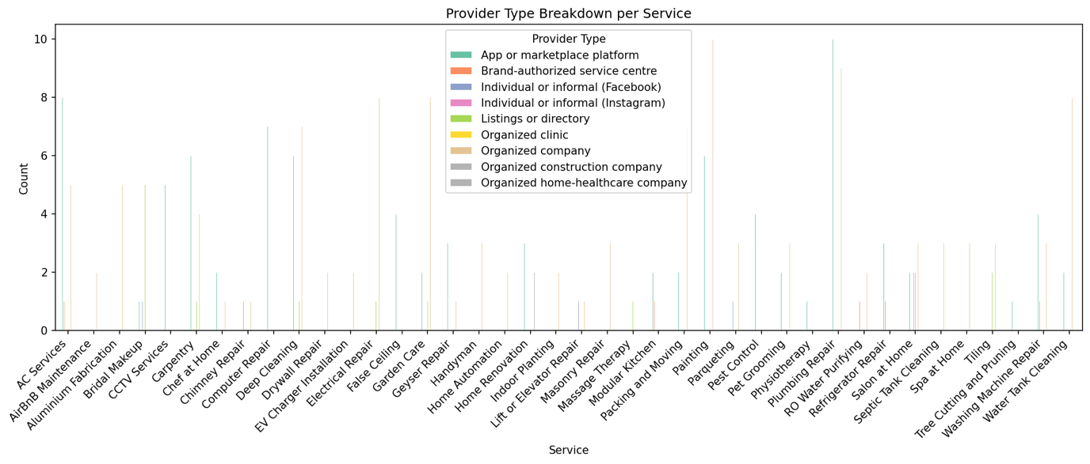
Figure 3: Provider Type Breakdown per Service

6. Conclusion
The on-demand home services market in Nepal is active and growing, but the competition is not spread evenly. A large portion of provider activity is concentrated in home repair, renovation, and technical services, where multiple organized companies and digital platforms are already competing for the same customers. At the same time, a significant number of categories including home automation, drywall repair, and AirBnB maintenance have barely any providers, which points to real gaps that the market has not yet addressed.
Organized companies remain the backbone of the market, but app-based platforms have grown close enough in share to suggest that digital service delivery is no longer an emerging trend but an established one. The presence of multi-category platforms like Sajilo Sewa, Technical Sewa, and SmartCare shows that some players have already recognized the value of covering the market broadly rather than specializing narrowly.
For anyone looking to enter this market, the data makes the landscape reasonably clear. The crowded categories require a strong differentiator to compete, while the underserved ones offer room to build a presence with little existing resistance. The structure of the market today reflects a sector that is maturing in some areas and still wide open in others.

